1. The Archean Nitrogen Cycle (3.5–2.5 Ga)

Current understanding of the Archean nitrogen cycle suggests that from **3.5 Ga to 2.9 Ga**, the primary nitrogen process in the ocean was **biological N₂ fixation**. However, the concentration of **NH₄⁺ remained relatively low**, as indicated by nitrogen isotope data, where δ¹⁵N values were approximately **0‰ for organic matter and 1.3‰ for sediments**. During this period, due to the **absence of strong oxidants, nitrification had not yet been widely established**. Instead, **Feammox (iron-mediated anaerobic ammonium oxidation) was likely a major nitrogen sink**, leading to the conversion of NH₄⁺ to N₂ and its subsequent loss to the atmosphere. This process may have **intensified the demand for biological N₂ fixation**, further strengthening nitrogen cycling to maintain the marine nitrogen balance (nitrostat).

Between **2.8 and 2.4 Ga**, nitrogen isotope records show a significant increase in δ¹⁵N_bulk to **5.8‰ (±8.5‰)** and δ¹⁵N_ker to **6.8‰ (±13.1‰)**. While some studies suggest δ¹⁵N values **remained as low as ~3‰** or even **near 0‰ in shallow waters**, implying an absence of widespread aerobic nitrogen cycling, the mainstream view holds that **oxygenic photosynthesis had emerged in shallow marine environments**, leading to localized oxygen accumulation and the onset of nitrification-denitrification processes. Although the **Great Oxidation Event (GOE) officially occurred between 2.4 and 2.3 Ga**, these data indicate that **localized oxygenation may have started earlier (~2.8 Ga)**, influencing nitrogen cycling.

However, during the **Neoarchean (2.77–2.7 Ga)**, several extreme δ¹⁵N signals were observed, ranging from **-11.2‰ to +50‰**. Possible explanations for these anomalies include:

1. **Global or localized oxygen increase**, leading to **nitrification-driven N₂O production, followed by denitrification further depleting NO₃⁻** (currently the most widely accepted hypothesis).
2. **NH₃ volatilization in alkaline environments**, similar to processes observed in modern alkaline lakes.
3. **Partial NH₄⁺ assimilation**, which could have enriched the remaining NH₄⁺ pool in ¹⁵N.

Since these processes could have occurred in different geographic and environmental settings, it remains challenging to distinguish their individual contributions. Furthermore, it is difficult to directly extrapolate these δ¹⁵N signals to represent global oceanic conditions. Nevertheless, from the **Neoarchean to the Paleoproterozoic**, the progressive oxidation of the **surface ocean** played a crucial role in driving nitrogen cycle evolution and **supporting the development of more complex biological systems**.

1. The Paleoproterozoic Transition (2.3–1.8 Ga)

During the **Paleoproterozoic (2.3–1.8 Ga)**, despite low atmospheric oxygen levels, δ¹⁵N increased from **2.6‰ to 8.8‰ (2.31–2.25 Ga)**, interpreted as evidence for the **widespread of aerobic nitrogen cycling**. Even in the **late Paleoproterozoic (~1.9 Ga)**, **δ¹⁵N values remained elevated** (δ¹⁵N_bulk = 4.9 ± 3.6‰, 1σ, n = 702; δ¹⁵N_ker = 3.8 ± 2.9‰, 1σ, n = 156), indicating the sustained availability of **NO₃⁻ in the ocean**. Previous studies have proposed two possible explanations for this phenomenon:

1. **High N₂ fixation rates**, which continuously supplied bioavailable nitrogen.
2. **Nitrogen retention mechanisms**, preventing substantial nitrogen loss.

For instance, some studies suggest that in **ferruginous ocean conditions**, **dissimilatory nitrate reduction to ammonium (DNRA)** was actively occurring in the water column, effectively recycling nitrogen within the system.

By the way, reports of nitrogen limitation have been largely **localized** rather than widespread.

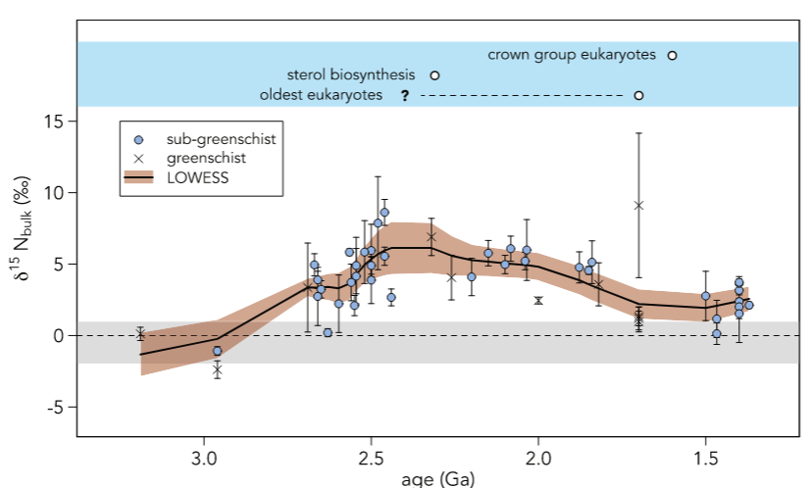

1. The Mesoproterozoic "Boring Billion" (1.8–0.8 Ga)

During the **Mesoproterozoic (~1.8–0.8 Ga)**, the ocean experienced a prolonged period of **biogeochemical stasis**, often referred to as the **“Boring Billion”**, during which eukaryotic evolution was slow. The prevailing hypothesis suggests that **NO₃⁻ limitation was a major factor restricting eukaryotic expansion**. The possible reasons include:

1. **Increased ocean sulfidation following the Great Oxidation Event (GOE)**, which **removed key trace metals such as molybdenum (Mo)**, an essential element for nitrogen fixation, thereby suppressing biological N₂ fixation and limiting NO₃⁻ availability.
2. **Spatial variability in δ¹⁵N records**:

* **In shallow, oxygenated environments**, δ¹⁵N values were relatively **high**, indicating a greater supply of NO₃⁻.
* **In deeper, anoxic environments**, δ¹⁵N values were **lower**, suggesting a more limited NO₃⁻ reservoir.

A recent perspective proposes that while deep-sea **NO₃⁻ availability was indeed limited, a moderate nitrate reservoir still existed**. This reservoir was **insufficient to drive extensive eukaryotic evolution** but was **enough to sustain low-level development**. Notably, even with a nitrate reservoir present, nitrogen limitation still **promoted biological** **N₂ fixation**, a scenario resembling modern oceanic conditions where nitrate is abundant but nitrogen remains limiting. Some studies also suggest **alternative Mo sources could have supported N₂ fixation**, allowing sustained but slow biological productivity.

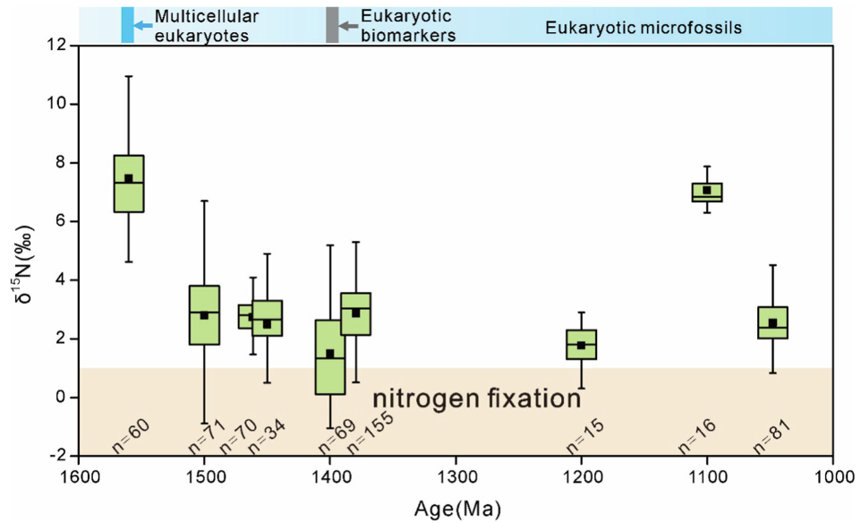

1. The Neoproterozoic Oxygenation (1.0–541 Ma)

In the **Neoproterozoic (~1.0–541 Ma)**, during the early period **(~1.0–0.7 Ga)**, nitrogen isotope values remained relatively low (**-1‰ to +3‰**), indicating that **NO₃⁻ availability was still restricted**, and oceanic conditions remained **similar to those of the earlier Precambrian**.

However, after **0.8 Ga**, due to the **Snowball Earth glaciations**, δ¹⁵N values began to increase, rising from **~1‰ to 7‰**. By the **Ediacaran period (~635–541 Ma)**, nitrogen isotope records **closely resembled modern values**, indicating that **NO₃⁻ availability had reached levels sufficient to support complex ecosystems**.

Key Scientific Questions:

**1, Was early ocean primary productivity limited by nitrogen or phosphorus?**

We propose that before the Great Oxidation Event (GOE), phosphorus was the primary limiting nutrient. As oxygen accumulated, it stimulated primary production while increasing nitrogen loss, promoting biological nitrogen fixation. GOE occurred when nitrogen and phosphorus reached equilibrium. After GOE, the NO₃⁻ reservoir expanded, but during the Mesoproterozoic, nitrogen became the dominant limiting factor for primary productivity. Despite enhanced nitrogen fixation, NO₃⁻ levels remained moderate.

**2, Can geological nitrogen isotope records be reliably reconstructed?**

Draft Abstract:

The oxygenation of Earth's atmosphere and oceans has been crucial to the evolution of life and surface environments. Studies suggest that rising oxygen levels were driven by increased phosphate availability, enhancing photosynthesis. Others propose that nitrogen became a key limiting nutrient due to restricted nitrogen fixation and nitrogen loss through early nitrification-denitrification. Consequently, the impact of evolving nitrogen and phosphorus limitations on Earth's oxygenation remains unclear. Here, we develop a long-term nitrogen cycle evolution framework based on a Precambrian ocean oxygen-carbon-phosphorus model, incorporating the combined constraints of nitrogen and phosphorus limitations on primary productivity and ocean anoxia. Our model provides a more accurate simulation of Earth's oxygenation trajectory and successfully reconstructs the dynamics of NH₄⁺ and NO₃⁻ reservoirs, the nitrogen-to-phosphorus ratio, and geological nitrogen isotope records. We propose that before the Great Oxidation Event (GOE), phosphorus was the primary limiting nutrient. As oxygen accumulated, it stimulated primary production while increasing nitrogen loss, promoting biological nitrogen fixation. GOE occurred when nitrogen and phosphorus reached equilibrium. After GOE, the NO₃⁻ reservoir expanded, but during the Mesoproterozoic, nitrogen became the dominant limiting factor for primary productivity. Despite enhanced nitrogen fixation, NO₃⁻ levels remained moderate. Overall, nitrogen as a limiting nutrient is essential in Earth's climate-nutrient models and key to understanding life’s evolution and planetary habitability.

Paper Structure

Introduction

1, The importance of the nitrogen cycle in Earth's oxygenation and the necessity of reconstructing a nitrogen cycle model.

2, The need to establish a framework for the combined control of primary productivity by nitrogen and phosphorus limitations.

3, The complexity of reconstructing geological nitrogen isotope records.

Result and discussion

I want to discuss the role of the nitrogen and phosphorus cycles in primary productivity separately before and after the GOE, but I have not yet found a clear structure. In addition, I have the following three issues that I am unsure how to address.

**•Exclusion of iron-driven ammonia oxidation, anaerobic ammonia oxidation (anammox), and dissimilatory nitrate reduction to ammonium (DNRA) in the model**

These nitrogen transformation processes are hypothesized to have occurred in early oceans. Both denitrification and anammox are considered significant nitrogen removal pathways, yet their isotopic fractionation effects are similar, making them difficult to distinguish in geological records.

Anammox relies on NO₂⁻ (nitrite), which primarily originates from ammonia oxidation. Consequently, the extent of anammox is closely tied to the availability of oxygen for ammonia oxidation. The omission of these processes in the model may lead to an incomplete representation of nitrogen cycle dynamics in early anoxic oceans.

•**Failure to reproduce extreme δ¹⁵N signals during the Neoarchean (2.77–2.7 Ga)**

The model does not capture the extreme nitrogen isotope excursions observed in the geological record for this period. In our simulations, δ¹⁵N increases nearly synchronously with rising oxygen levels due to water-column denitrification.

However, prior to the increase in oxygen and δ¹⁵N, our model does show a decline in ammonia concentrations. This aligns with previous hypotheses suggesting that partial oxidation of ammonia to N₂O (nitrous oxide) could have induced significant isotopic fractionation.

**•Factors controlling nitrogen fixation in the Proterozoic**

The model results are consistent with geological data, indicating that NO₃⁻ remained relatively available in both the early and late Paleoproterozoic.

However, the model does not incorporate the influence of sulfidic conditions on molybdenum (Mo) availability. In the Mesoproterozoic, sulfidic waters could have removed Mo from the ocean, thereby limiting nitrogen fixation—a process that we cannot simulate in our current framework.

Additionally, in our model, nitrogen fixation does not increase indefinitely under extreme nitrogen limitation. As a result, both NO₃⁻ concentrations and nitrogen isotopes remain relatively stable throughout the Mesoproterozoic, which is consistent with recent studies suggesting moderate NO₃⁻ levels during this time.

Notably, if we impose a forced decline in nitrogen fixation efficiency to 30% post-GOE, the model predicts reductions in oxygen, NO₃⁻, and nitrogen isotope values, aligning with previous findings. In particular, atmospheric oxygen decreases from 40% PAL to 10% PAL, which falls within the widely accepted range of 0.1–10% PAL suggested by other studies.

